Chemistry VR

P1 – Conceptual Model

Members: Elizabeth Dayton, Cole Beck, Byeonghyeon Choi, Nick Arnold, Jay Cieutat, Ben Dempsey, Everett Clemons, and Joshua Gatlin

Abstract

Our project is a VR chemistry station. When the application is first started, they will be in an entrance room where they must first login and then they can choose between different kinds of labs to do at a chemistry station. To start with, this chemistry station will be capable of completing the redox titration chemical reaction. The user of our VR app will have limited control of the chemistry station and will be mostly guided through the lab. If they make a certain number of mistakes, our system will give more and more descriptive hints until they complete the lab correctly. The user should get feedback when they make mistakes as well. There will also be a notepad to record data while completing the experiment. Finishing the lab correctly will present them with a congratulations message and the options to either reset the lab or to go back to the main menu to select a different lab to complete.

The purpose of this application is to introduce the experiment to the student before they go to complete the lab in person. Most students make mistakes when completing this lab. This VR prelab can help reduce chemical waste when they go to complete the lab in person. The student should be familiar with the experiment after using our application and will hopefully be less likely to make a mistake, or as many mistakes, when they complete it in person.

Project Schedule

Complete by October 23rd: P1- Conceptual Model

Complete by October 28th: P2 – Preliminary Papers

Complete by November 5th: P3 – Usability Testing and Evaluation Rubrics

Complete by November 21st: P4 – Final Presentation

Complete by November 24th: P5 – Update Project Report [P2 revised and updated]

Hardware and Software Requirements

Hardware (if it is VR that requires PC):

* Graphics card: GTX 1060/AMD RX 470/570 or greater
* CPU: Intel Core i5-4590/AMD Ryzen 5 1400 or greater
* Memory: 8GB but recommend 16GB
* AIO: HDMI 2.0, DisplayPort 1.2, USB 3.0, USB c,
* OS: Windows
* VR Headset: Valve Index, Oculus Rift, Oculus Quest, HTC, and more
* Controller: VR controller

Software:

* Chemistry VR application

Lexicon

The user will need to aware of jargon concerning the chemistry experiment itself. They will need to be familiar with chemistry lab equipment as well as the chemicals needed to complete the experiment. These include, but are not limited to, potassium permanganate solution, beaker, molarity, burette, KMnO4, Erlenmeyer flask, hydrogen peroxide, graduated cylinder, and meniscus.

Potassium permanganate solution, or KMnO4, is a chemical compound that combines manganese oxide ore with potassium hydroxide. It was originally used as a disinfectant and is still used to treat skin conditions like fungal infections.

A beaker is a lipped cylindrical glass container for laboratory use.

Molarity is the number of moles of solute per liter of solution, which can be calculated using the following equation: molarity = mol of solute / liters of solution. A mole is a standard scientific unit for measuring large quantities of very small entities such as atoms, molecules, or other specified particles.

A burette is a graduated glass tube with a tap at one end, for delivering known volumes of a liquid, especially in titrations.

An Erlenmeyer flask is a conical flat-bottomed laboratory flask with a narrow neck.

Hydrogen peroxide is a colorless, viscous, unstable liquid with strong oxidizing properties, commonly used in diluted form in disinfectants and bleaches.

A graduated cylinder, also known as measuring cylinder or mixing cylinder, is a common piece of laboratory equipment used to measure the volume of a liquid. It has a narrow cylindrical shape. Each marked line on the graduated cylinder represents the amount of liquid that has been measured.

A meniscus is the curved upper surface of a liquid in a tube.

Interaction Style and Type

Style: Virtual Reality

Type: Manipulation

Interface Metaphor

A glove or pointer will be the main interface metaphor representing the locus of interaction, similar to a cursor on a computer screen.

A notebook icon can indicate where the information that would be stored in a lab notebook after each step of information gathering can be found.

Downward pointed triangles on buttons at the top of the screen indicate that the buttons can drop down into a menu of multiple options.

For the web version of the app, a log in screen will have a typical white bar with a flashing black line indicating that something can be typed in that space.

Software Development Process

The type of software development process that we will be using is the XP (EXTREME PROGRAMMING) methodology.

Using XP we will be able to manage our client’s rapid introduction of ideas into the system.

XP is also the right choice in terms of development process because it allows the team to work closely together. This will be done through means such as pair programming. Since we have a limited timeframe to complete the project it would be wise to combine our efforts.

All of the advantages of XP, such as ability to continuously evaluate our specifications in regards to the demands of our client, will benefit our productivity greatly. The disadvantages of XP programming also will not affect us in this instance. Issues such as requiring a closely-knit team and geographic location will not be a problem for our development team.

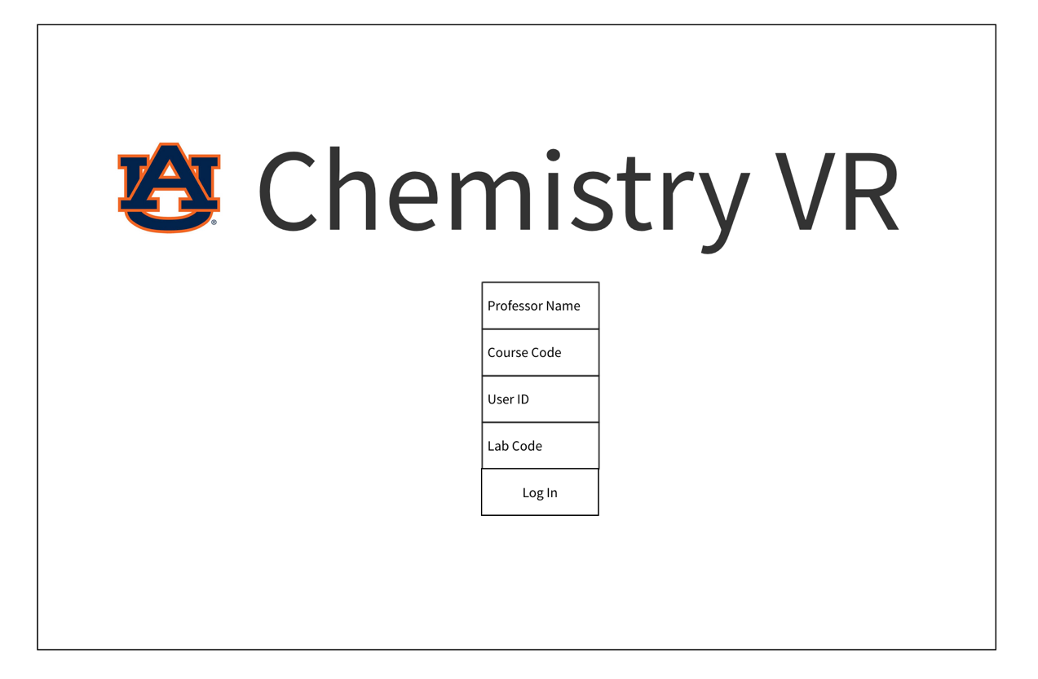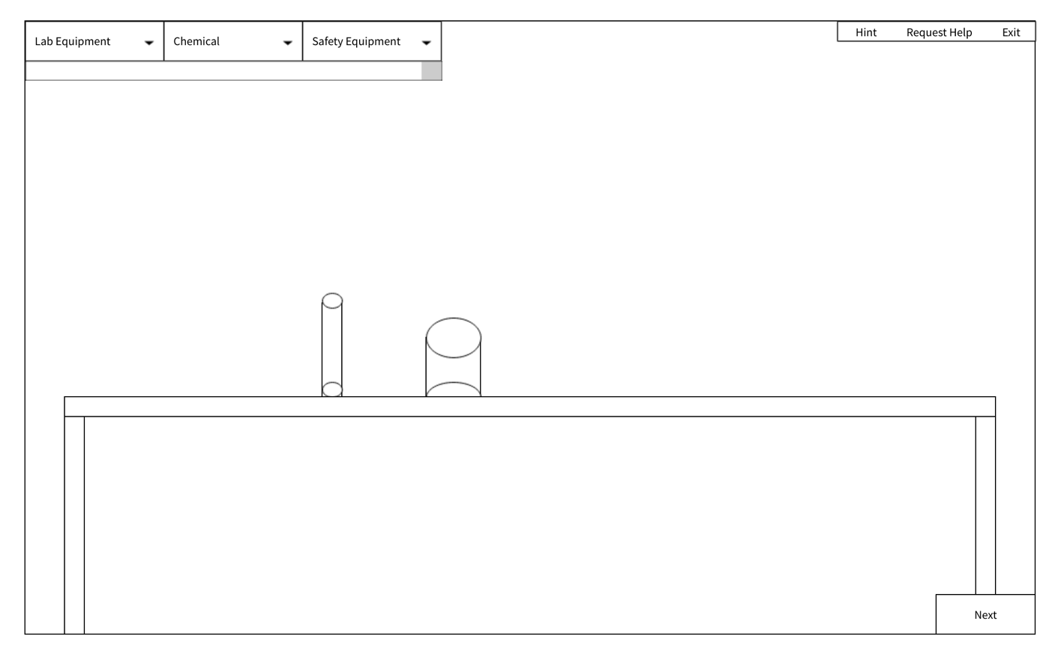Wireframes

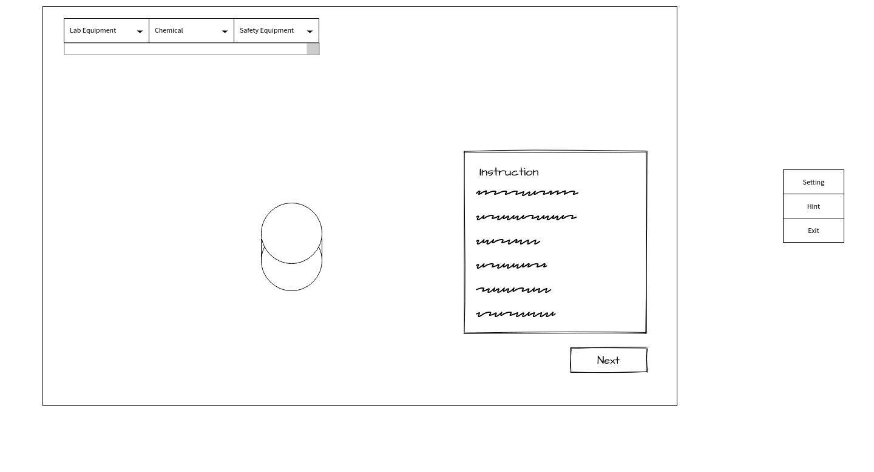

Persona

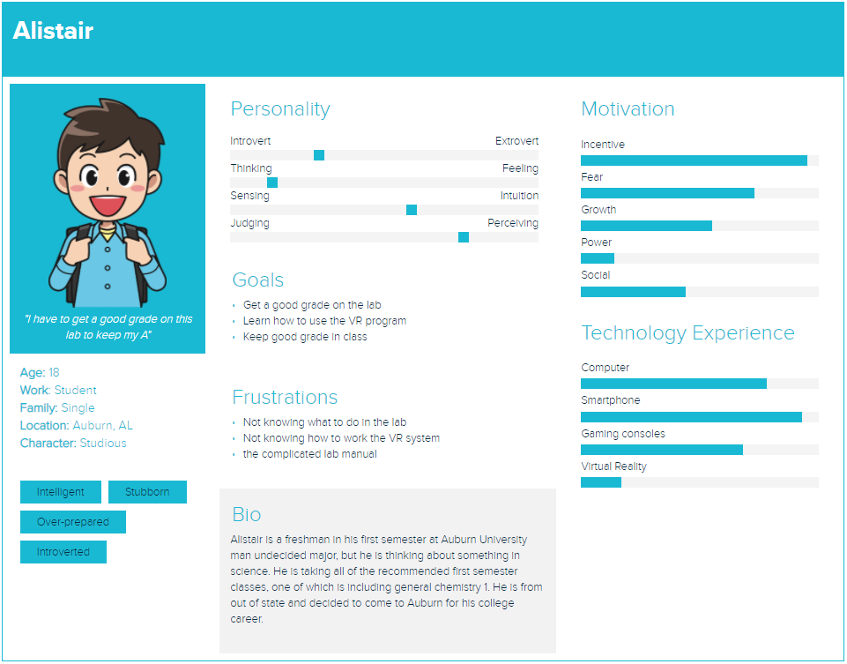

Empathy Map

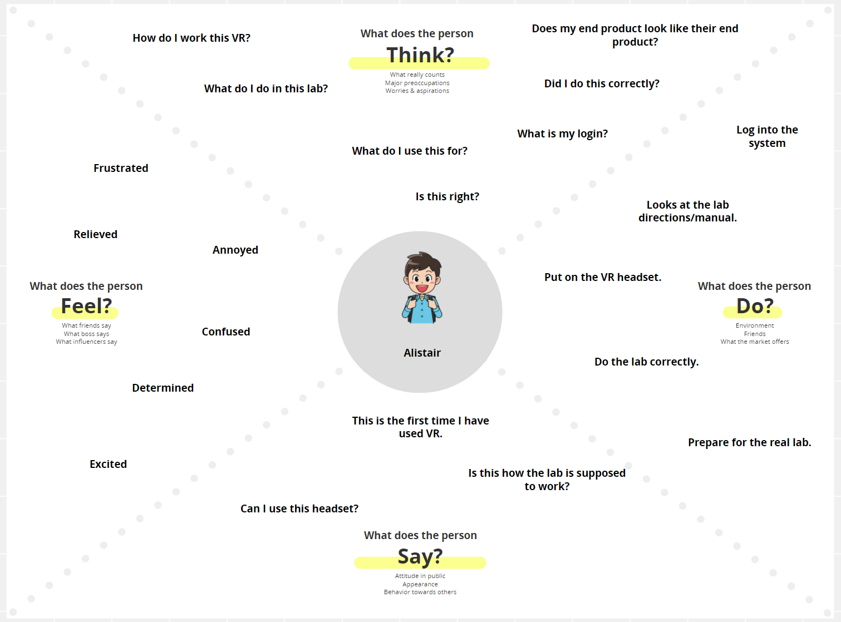

Scenarios

Scenario #1: A student, Alistair, will open up our application on his VR headset to complete his prelab on redox titration. He’s never used VR before and is nervous about trying to figure out VR and the lab. Upon opening the application, he is met with a login screen. He enters his school provided credentials for his student account and is now in the main entrance room. From there, he selects the redox titration lab and is moved to an appropriate chemistry station. He completes the lab with the help of some hints along the way and retries it two more times to make sure he understands it completely. He then goes back to the main room, logs out, and removes his VR headset.

Scenario #2: A teacher, Dr. Cuddlesworth, wants to see if our VR application will be sufficient for his students learning. He purchases a VR headset for this very purpose. He loads up our application on his new headset. He logins in with his credentials and navigates to the appropriate reaction, redox titration. He completes the reaction exactly the way he’s supposed to and then retries several times to see how helpful the system is at guiding someone who can’t figure it out. Satisfied, he moves back to the main screen and previews other labs available for future use before he logs off.